BIOLOGY DEPT
Namungoona salaf
Growth and Development test 1

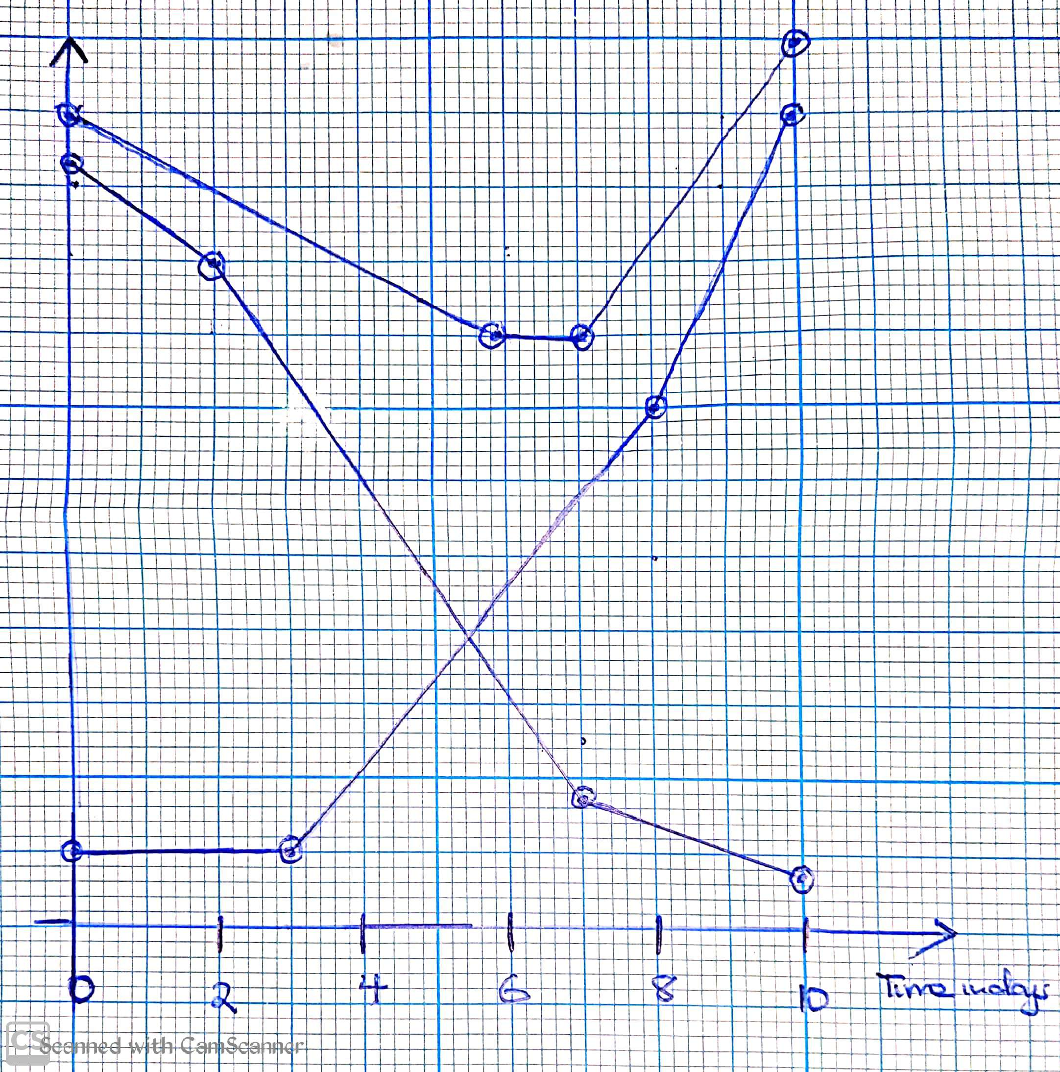
1.The graph below shows the relative changes in dry mass of the embryo and endosperm during germination of a maize seed in a well illuminated environment
Dry mass (grams
Embryo
Endosperm
Total dry mass

a) compare the dry mass of the endosperm and embryo(06mrks)
................................................................................................................................
................................................................................................................................
...............................................................................................................................
................................................................................................................................
b) Explain the the changes in each of the following during germination of the maize seed
i) Dry mass of the endosperm (05mrks)
...............................................................................................................................
................................................................................................................................
...............................................................................................................................
................................................................................................................................
...............................................................................................................................
................................................................................................................................
ii) Dry mass of the embryo (05mrks)
...............................................................................................................................
................................................................................................................................
...............................................................................................................................
................................................................................................................................
1...............................................................................................................................
................................................................................................................................
iii) Total dry mass (04mrks)
...............................................................................................................................
................................................................................................................................
...............................................................................................................................
................................................................................................................................
...............................................................................................................................
................................................................................................................................
2. In an experiment to investigate a biological process, the following procedures were carried out using retorts
Setups | Treatments
A | Dry seeds introduced in the bulb of the retort and its tube dipped into a beaker filled with caustic potash solution
B | Soaked seeds introduced into the bulb of the retort and its tube dipped into a beaker filled with salt solution
C | oaked seeds introduced into the bulb of the retort and its tube dipped into a beaker filled with caustic potash

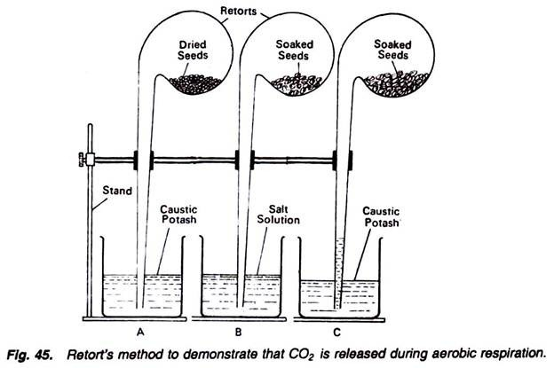

a) What is the aim of the above experiment (01mrk)
................................................................................................................................
................................................................................................................................
b) Give an account for the observations made in the setups at the end of the experiment
i) Setup A (02mrks)
................................................................................................................................
................................................................................................................................
................................................................................................................................
ii) Setup B (03mrks)
................................................................................................................................
................................................................................................................................
................................................................................................................................
iii) Setup C (02mrks)
................................................................................................................................
...............................................................................................................................
..............................................................................................................................
c) State the importance of soking the seeds in setup B and C (02mrks)
................................................................................................................................
................................................................................................................................
3a). Define a seed? (02mrks)
................................................................................................................................
................................................................................................................................
b) State 3 roles of seeds to flowering plants (03mrks)
.............................................................................................
............................................................................................
..........................................................................................
c) State any two causes of seed dormancy which originate within the seed (02mrks)
...................................................................................
....................................................................................
d) Write short notes about the following parts of the seed (03mrks)
i) Testa
................................................................................................................................
................................................................................................................................
ii) Hilum
................................................................................................................................
................................................................................................................................
ii) Coleorhiza
................................................................................................................................
................................................................................................................................
Section c
4 Describe any 8 factors that determine growth in living organism
5.Describe an experiment to show that growth in roots occurs at the tip
6a) What is meant by the following terms
i) Germination
ii) Seed dormancy
b) State the diffeent ways of breaking seed dormancy
c)Describe how the stored food in the cotyledons is utilised by the embryo of the seed

Stay home
Always sanitise where possible
Avoid crowded areas
Always put on a safety mask when moving

